Assignment 5 :
- Github Link :
- README.md Link :

Question 1 : Mux 2 to 1
Verilog code :
module mux_2_to_1_behavioral (
input wire a,
input wire b,
input wire sel,
output reg y
);
always @(sel, a, b) begin
if (sel)
y = a;
else
y = b;
end
endmodule

Testbench code :
`include "mux_2_to_1_behavioral.v"
module mux_2_to_1_behavioral_tb;
reg a, b, sel;
wire y;
mux_2_to_1_behavioral uut (.a(a), .b(b), .sel(sel), .y(y));
initial begin
$dumpfile("mux_2_to_1_behavioral_tb.vcd");
$dumpvars(0, mux_2_to_1_behavioral_tb);
$monitor("Time = %0t | a=%b b=%b sel=%b | y=%b", $time, a, b, sel, y);
#0 a = 0; b = 0; sel = 0;
#10 a = 0; b = 1; sel = 0;
#10 a = 1; b = 0; sel = 0;
#10 a = 1; b = 1; sel = 0;
#10 a = 0; b = 0; sel = 1;
#10 a = 0; b = 1; sel = 1;
#10 a = 1; b = 0; sel = 1;
#10 a = 1; b = 1; sel = 1;
#10 $finish;
end
endmodule

Compilation and Simulation Snapshot :
From the screenshot we observe for every 10 nanoseconds there is change in the output variable y. The selection when sel = 0 then we select the variable b and when sel = 1 then we select the variable a.
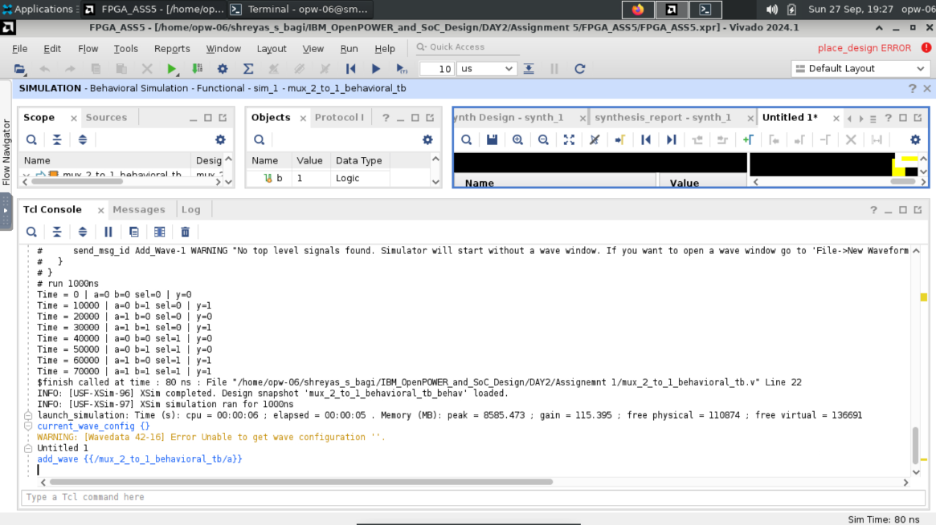

Waveform Window Snapshot : The same above what is observed in the log file even captured in the waveform window also.
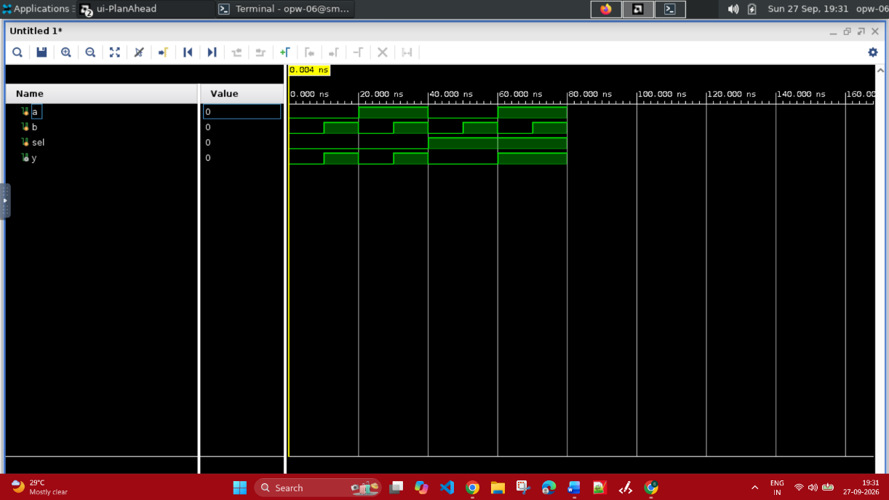

Question 2 :
Design a self-checking testbench for a 4-bit Magnitude Comparator and simulate using Vivado.
Verilog Code :
module comparator_4bit (
input [3:0] a,
input [3:0] b,
output reg a_greater,
output reg b_greater,
output reg equal
);
always @(*) begin
a_greater = 1'b0;
b_greater = 1'b0;
equal = 1'b0;

if (a[3] != b[3]) begin
a_greater = a[3];
b_greater = b[3];
end else if (a[2] != b[2]) begin
a_greater = a[2];
b_greater = b[2];
end else if (a[1] != b[1]) begin
a_greater = a[1];
b_greater = b[1];
end else if (a[0] != b[0]) begin
a_greater = a[0];
b_greater = b[0];
end else begin
equal = 1'b1;
end
end
endmodule

Testbench Code :
`timescale 1ns/1ps

module comparator_4bit_tb;

reg [3:0] a;
reg [3:0] b;
wire a_greater;
wire b_greater;
wire equal;

integer input_value_a;
integer input_value_b;
integer random_value_a;
integer random_value_b;
integer random_test_index;
integer random_seed;
integer test_count;
integer failure_count;

comparator_4bit dut (
.a(a),
.b(b),
.a_greater(a_greater),
.b_greater(b_greater),
.equal(equal)
);

task automatic check_case;
input [3:0] test_a;
input [3:0] test_b;
begin
a = test_a;
b = test_b;
#1;

test_count = test_count + 1;

if (test_a > test_b) begin
$display("Test %0d: A=%0d, B=%0d -> A > B | result: a_greater=%b b_greater=%b equal=%b",
test_count, test_a, test_b, a_greater, b_greater, equal);
if ({a_greater, b_greater, equal} !== 3'b100) begin
$display("FAIL: expected A > B, got %b", {a_greater, b_greater, equal});
failure_count = failure_count + 1;
end
end else if (test_a < test_b) begin
$display("Test %0d: A=%0d, B=%0d -> A < B | result: a_greater=%b b_greater=%b equal=%b",
test_count, test_a, test_b, a_greater, b_greater, equal);
if ({a_greater, b_greater, equal} !== 3'b010) begin
$display("FAIL: expected A < B, got %b", {a_greater, b_greater, equal});
failure_count = failure_count + 1;
end
end else begin
$display("Test %0d: A=%0d, B=%0d -> A == B | result: a_greater=%b b_greater=%b equal=%b",
test_count, test_a, test_b, a_greater, b_greater, equal);
if ({a_greater, b_greater, equal} !== 3'b001) begin
$display("FAIL: expected A == B, got %b", {a_greater, b_greater, equal});
failure_count = failure_count + 1;
end
end
end
endtask

initial begin
$dumpfile("4bit_comparator_tb.vcd");
$dumpvars(0, comparator_4bit_tb);

test_count = 0;
failure_count = 0;
random_seed = 32'h1ACE_B00C;

$display("Starting 20 deterministic random comparator tests...");
for (random_test_index = 0; random_test_index < 20; random_test_index = random_test_index + 1) begin
random_value_a = $random(random_seed) & 4'hf;
random_value_b = $random(random_seed) & 4'hf;
check_case(random_value_a, random_value_b);
end

$display("Starting 256-case exhaustive comparator test...");

for (input_value_a = 0; input_value_a < 16; input_value_a = input_value_a + 1) begin
for (input_value_b = 0; input_value_b < 16; input_value_b = input_value_b + 1) begin
check_case(input_value_a, input_value_b);
end
end

if (failure_count == 0) begin
$display("PASS: %0d random and exhaustive comparator tests completed successfully.", test_count);
end else begin
$display("FAIL: %0d of %0d comparator tests failed.", failure_count, test_count);
$fatal(1);
end

$finish;
end
endmodule

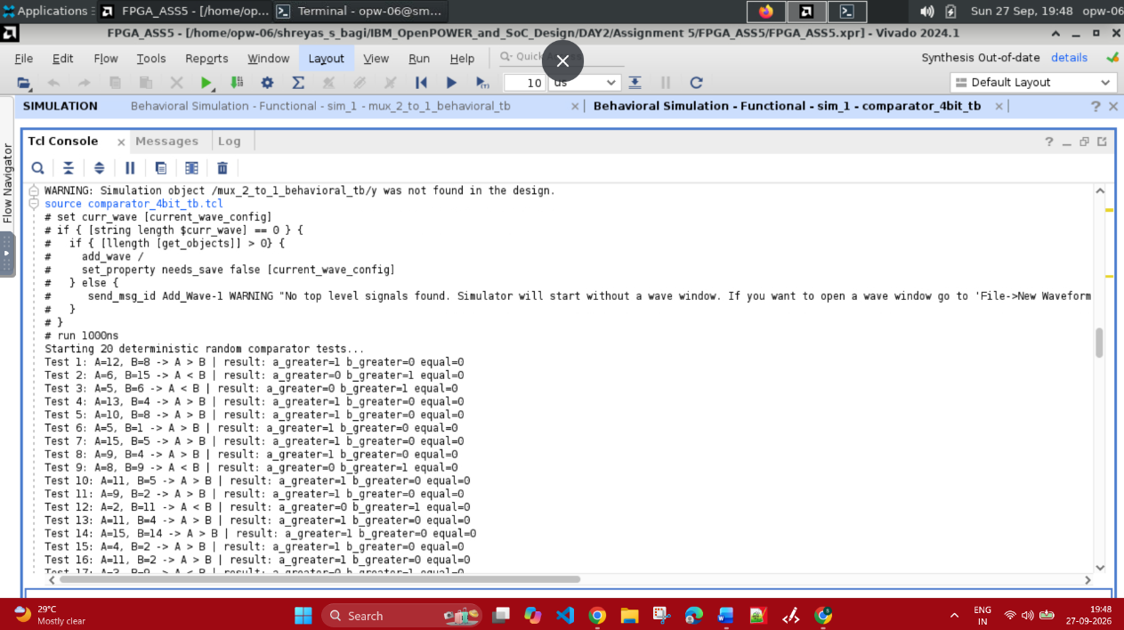
Compilation and Simulation :

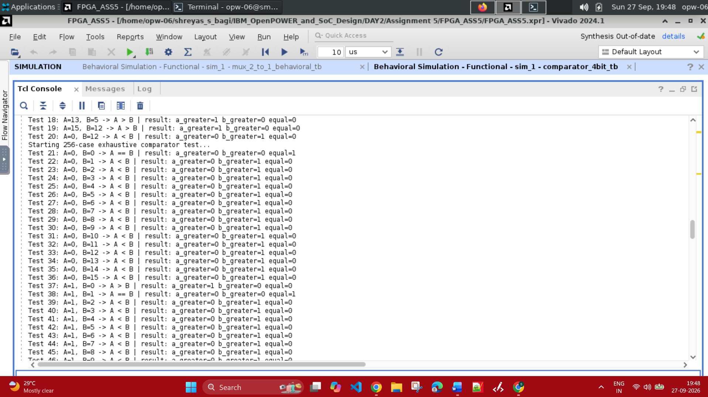

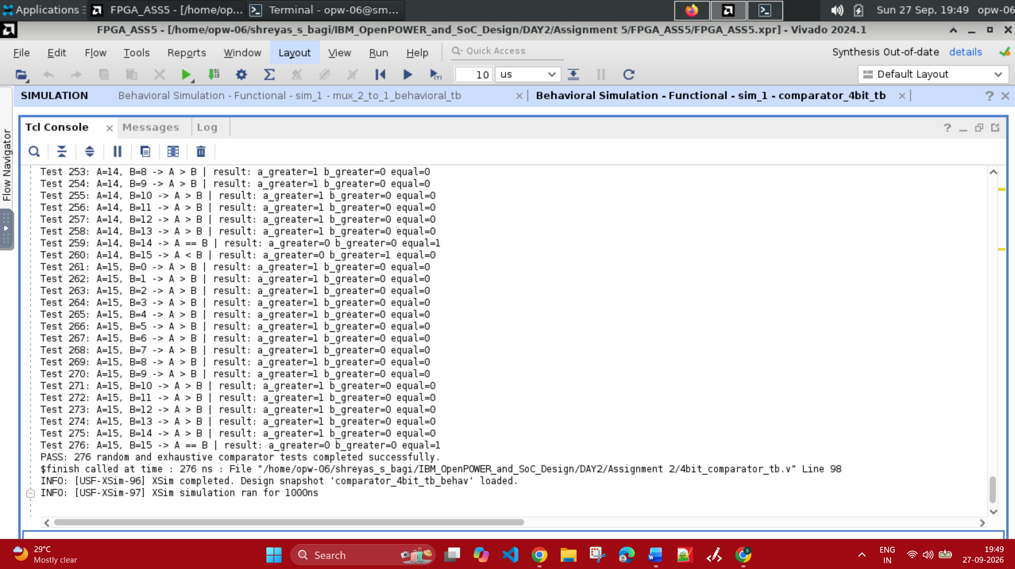

Simulation Waveform :
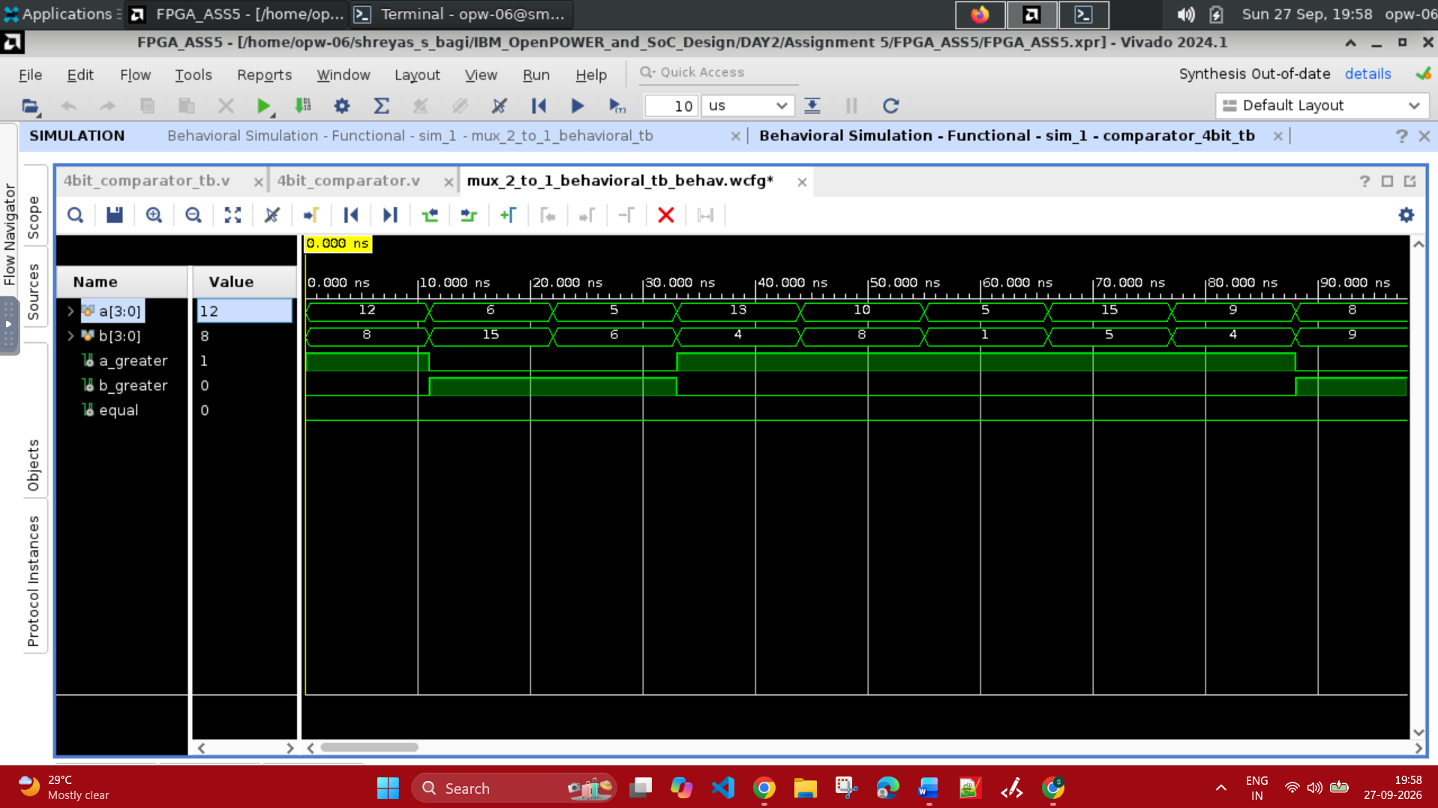

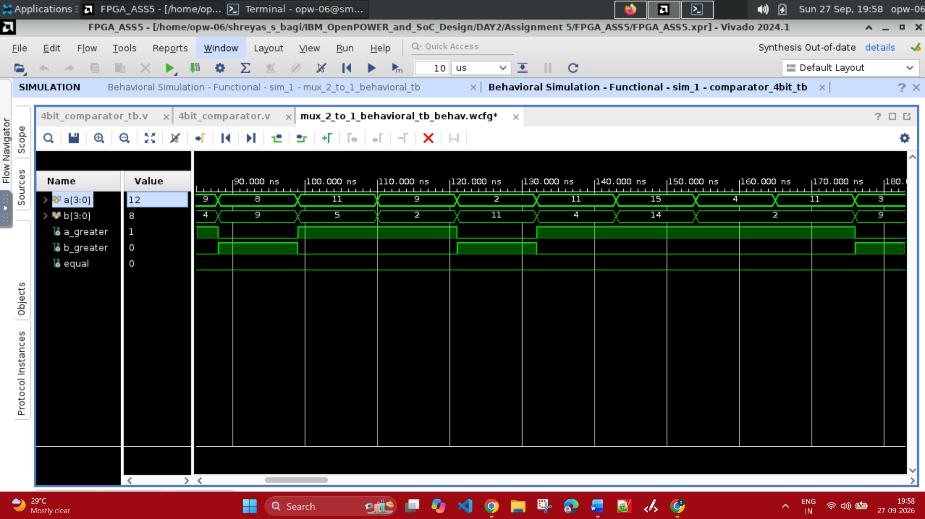

Question 3 :
Write a complete testbench for a D Flip-Flop with synchronous reset and simulate in Vivado.

Verilog code :
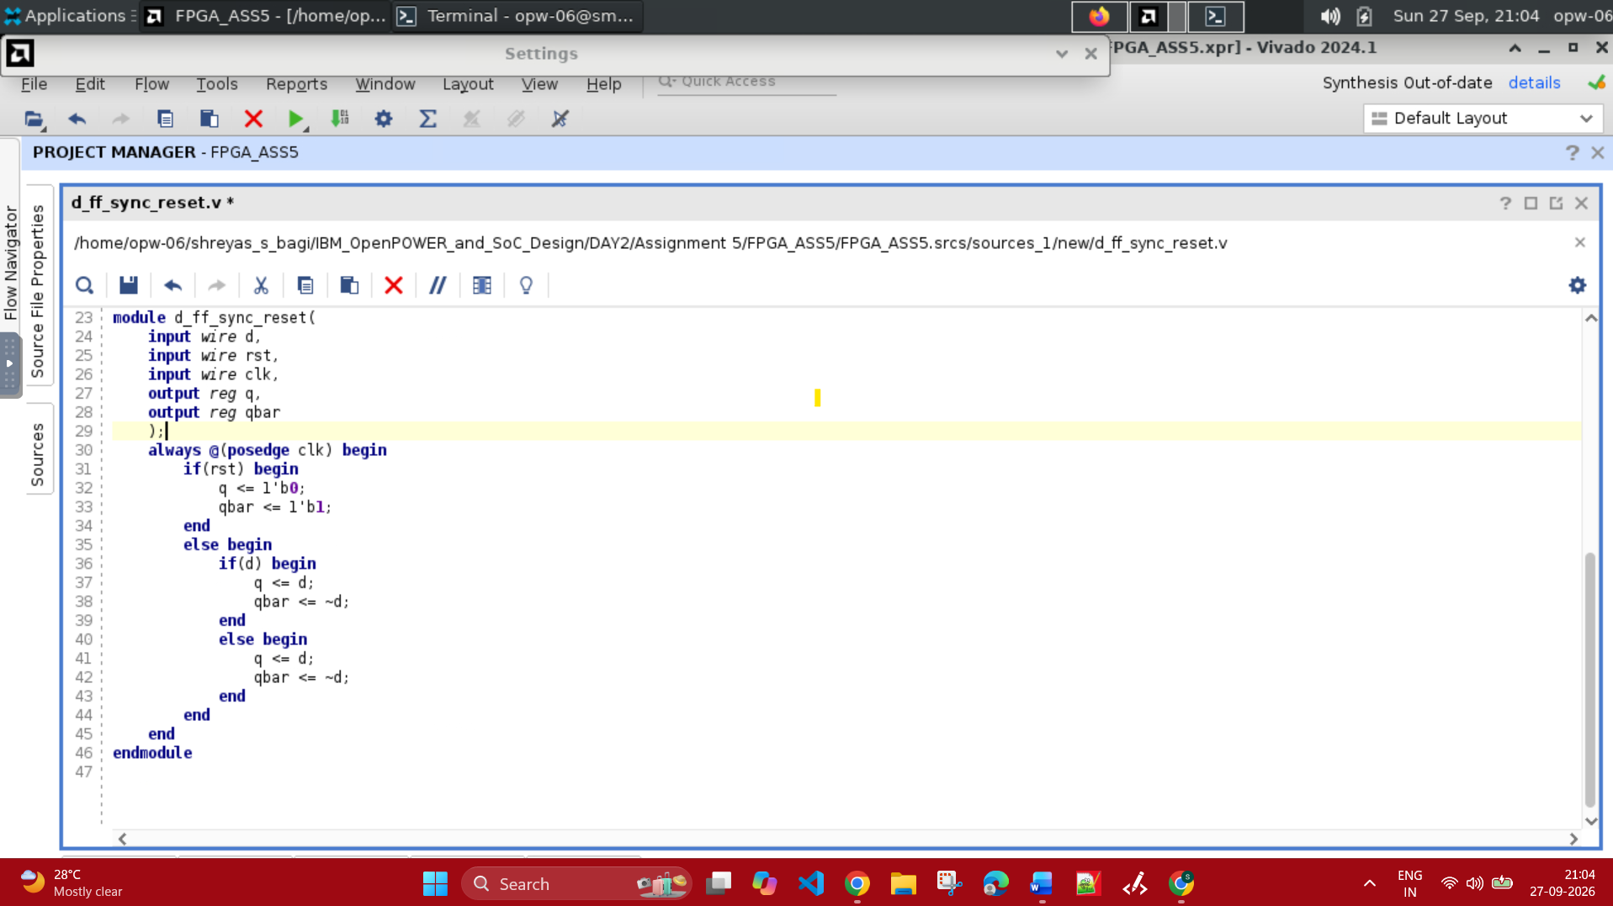

Testbench code :
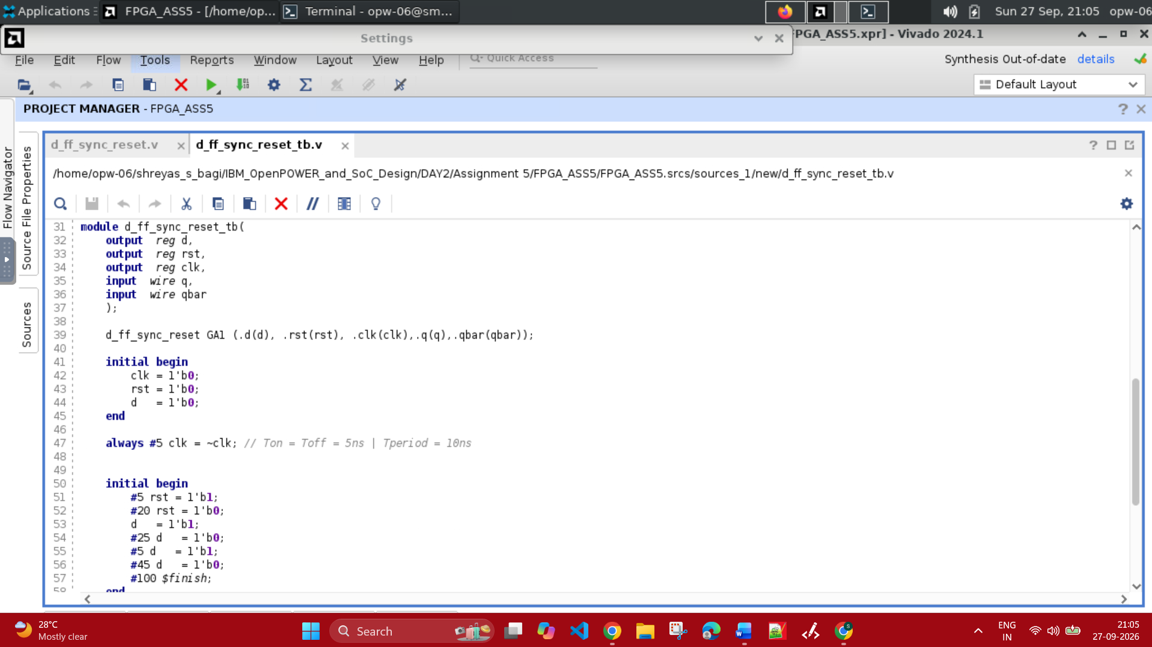

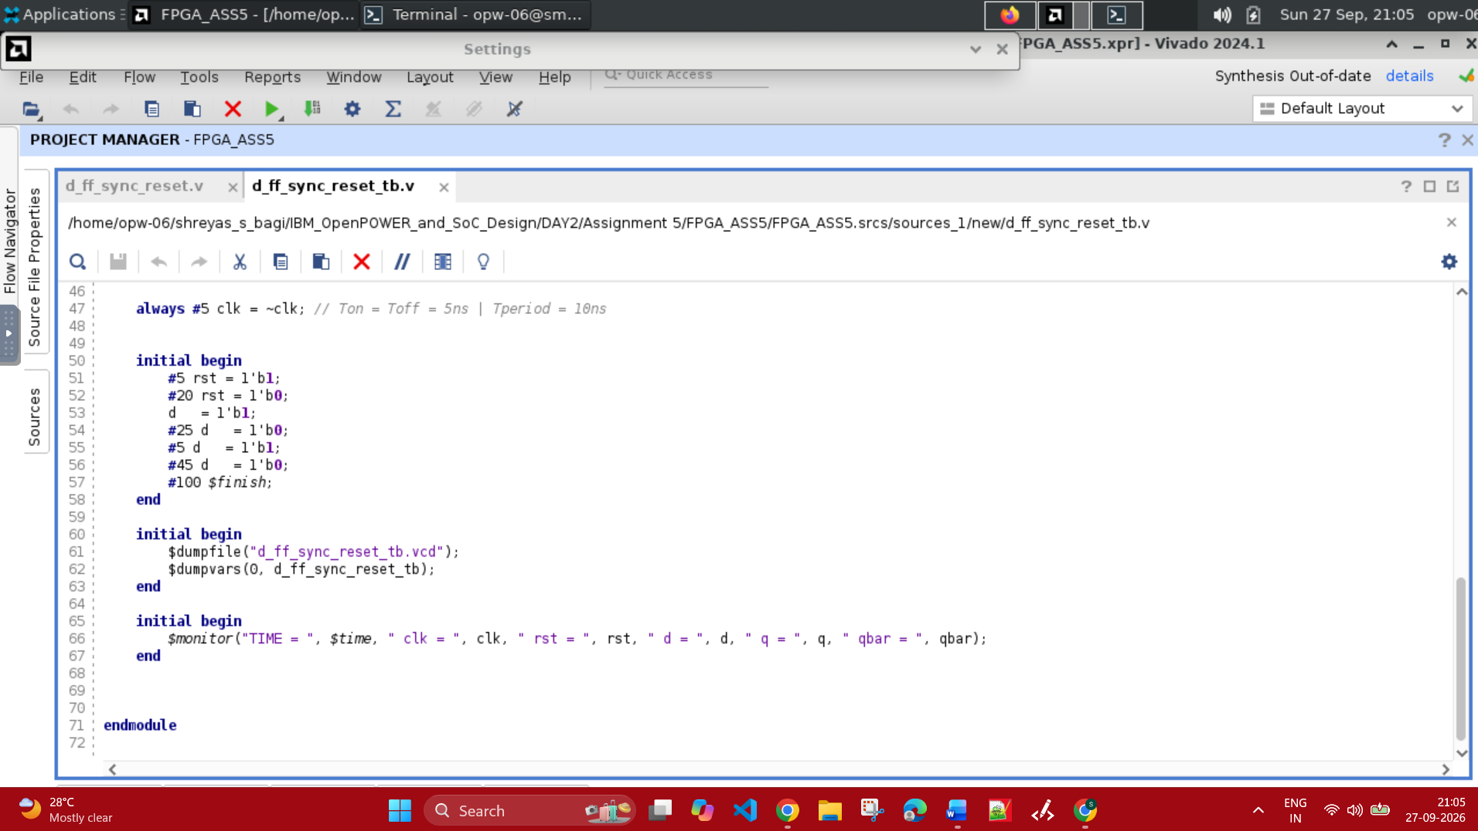

Compilation and Simulation Output :
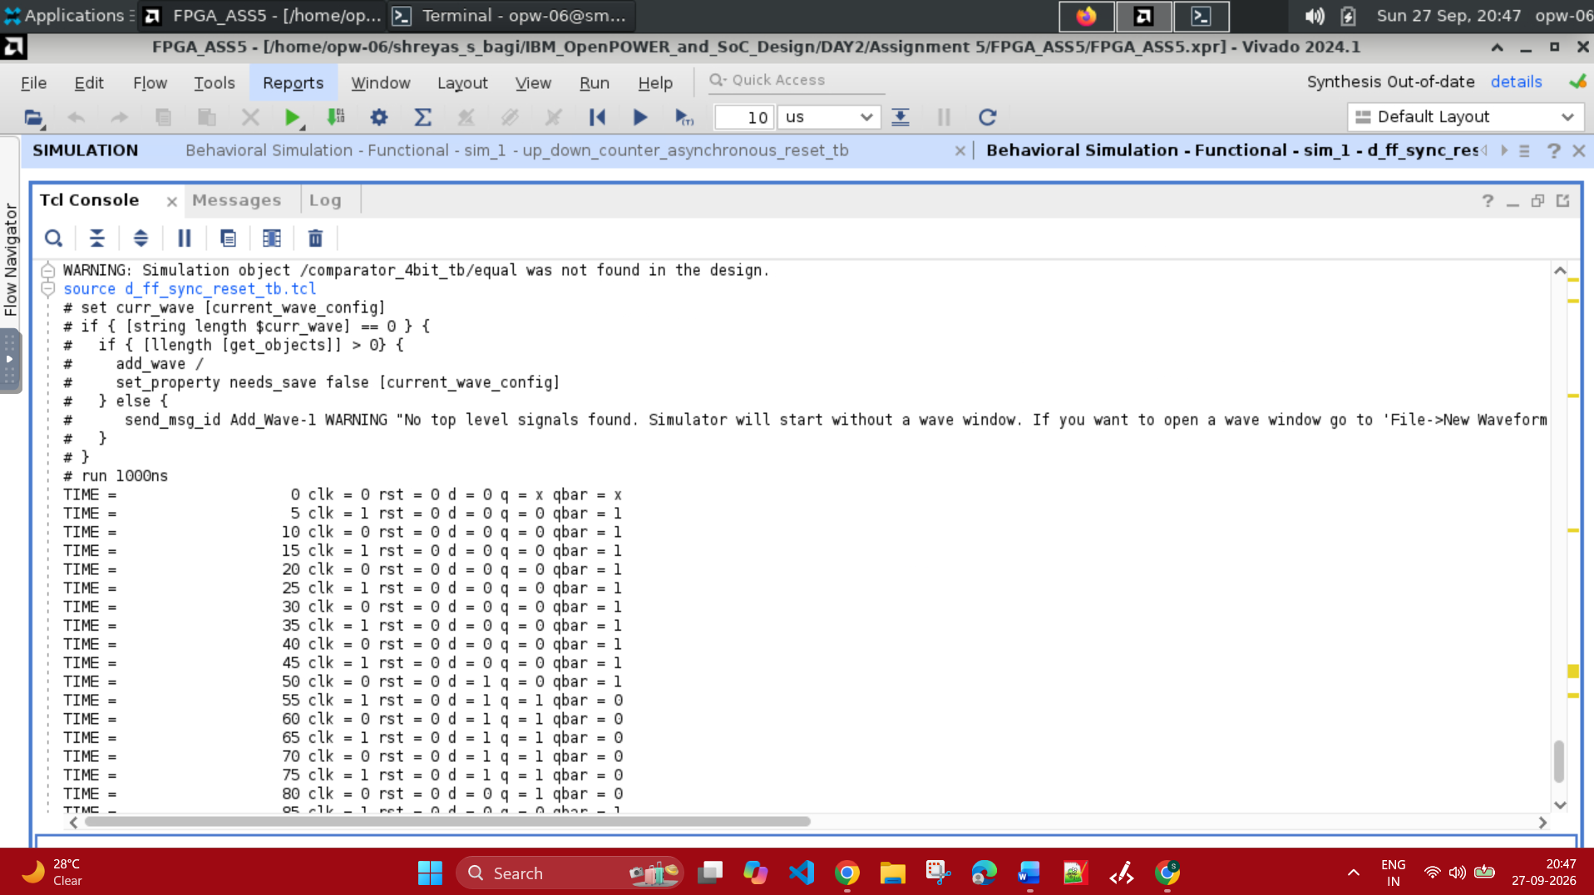

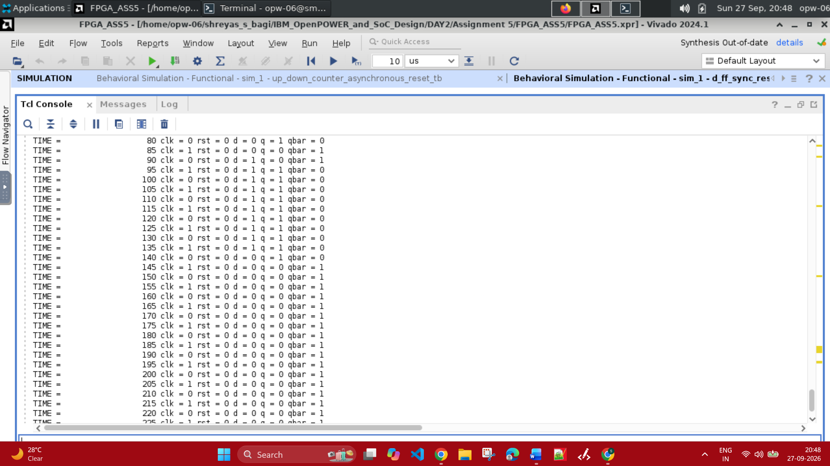

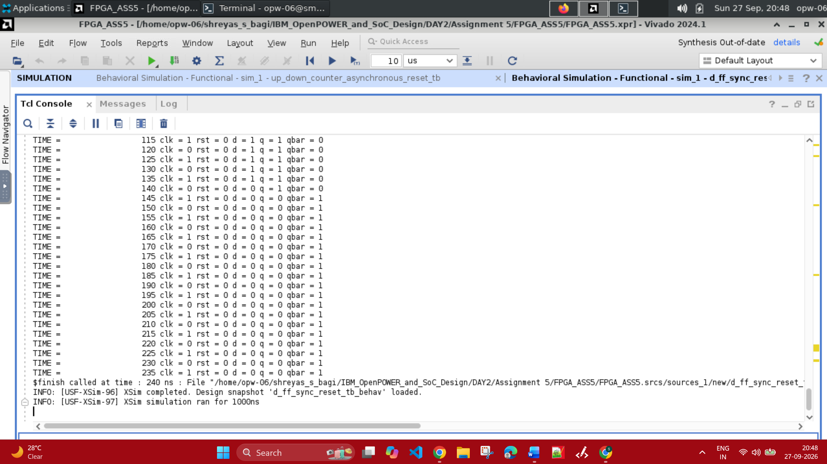

Simulation Waveform :
First two clk edges rst is applied then we see the D Flip Flop is Synchronous reset.
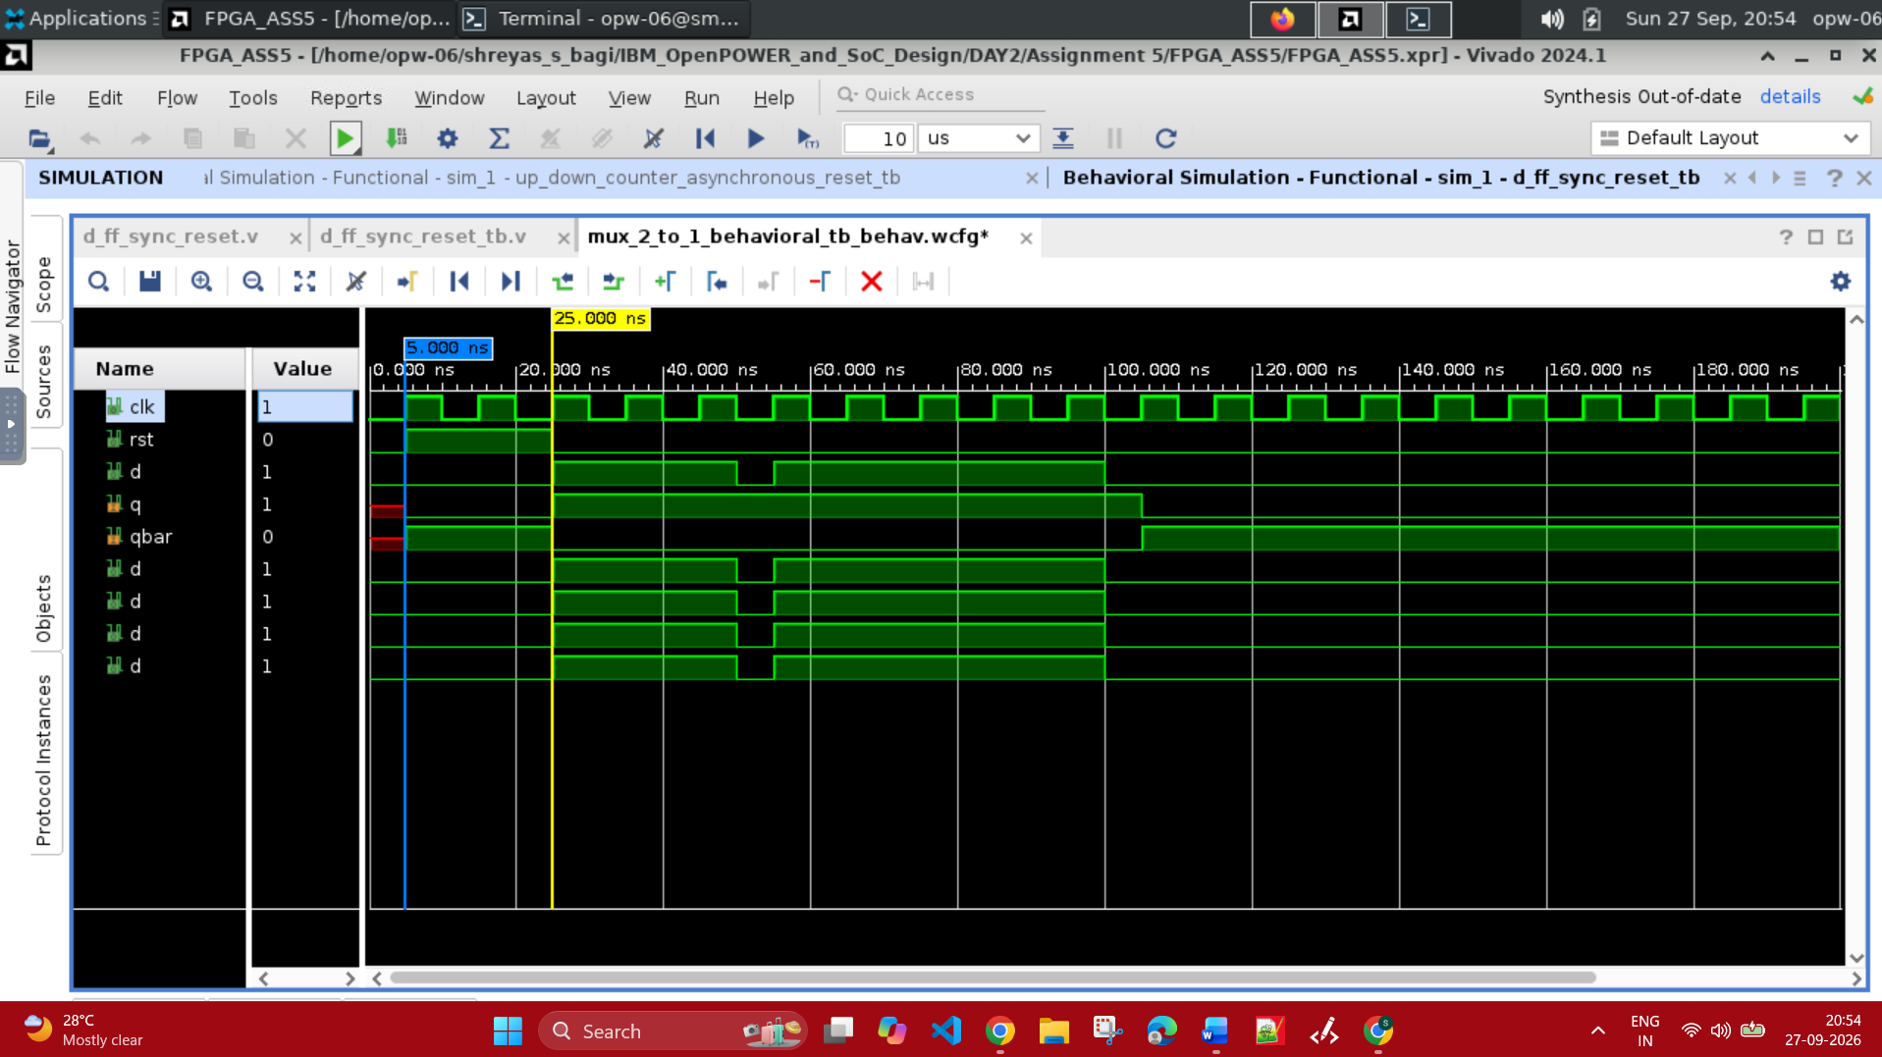

At clk = 25ns to 100ns we observe that d = 1 on every posedge of the clock and stuff hence we see q =1 and qbar = 0. At clk = 105ns we observe that d = 0 on every posedge of the clock and stuff hence we see q = 0 and qbar = 1.
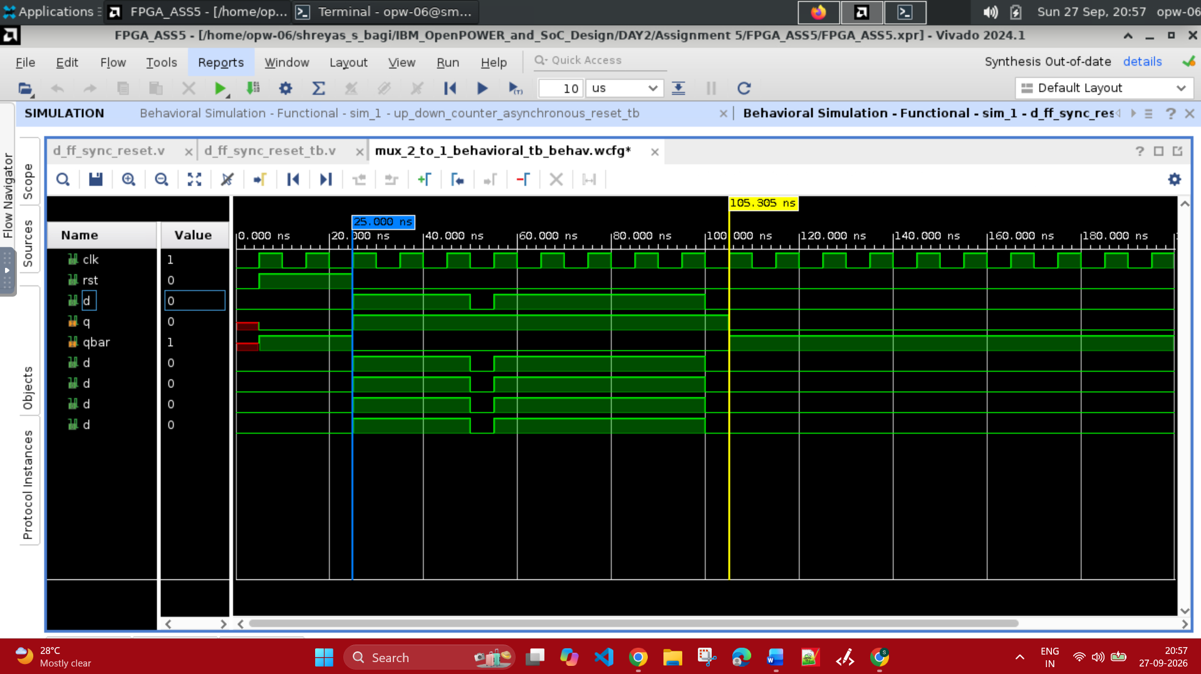

Question 4 :
Write and simulate a testbench for the 4-bit Up/Down Counter (Assignment 04) in Vivado.

Verilog Code :
module up_down_counter_asynchronous_reset (
input clk,
input reset,
input up,
output reg [3:0] count
);
always @(posedge clk or posedge reset) begin
if (reset)
count <= 4'b0000;
else if (up)
count <= count + 4'b0001;
else
count <= count - 4'b0001;
end
endmodule

Testbench Code :
/* Testbench for the asynchronous-reset up/down counter. */
`timescale 1ns/1ps
module up_down_counter_asynchronous_reset_tb;
reg clk;
reg reset;
reg up;
wire [3:0] count;
integer test_count;
integer failure_count;
integer value;
reg [87:0] mode;

up_down_counter_asynchronous_reset dut (
.clk(clk),
.reset(reset),
.up(up),
.count(count)
);

always #5 clk = ~clk;

task check_count;
input [3:0] expected_count;
begin
#1;
test_count = test_count + 1;

if (reset)
mode = "ASYNC RESET";
else if (up)
mode = "UP COUNT";
else
mode = "DOWN COUNT";

if (count !== expected_count) begin
$display("FAIL: Test %0d | %s | Expected=%b | Got=%b",
test_count, mode, expected_count, count);
failure_count = failure_count + 1;
end else begin
$display("PASS: Test %0d | %s | Count=%b",
test_count, mode, count);
end
end
endtask

initial begin
$dumpfile("4_bit_up_down_asynchronous_reset_tb.vcd");
$dumpvars(0, up_down_counter_asynchronous_reset_tb);

clk = 1'b0;
reset = 1'b0;
up = 1'b1;
test_count = 0;
failure_count = 0;

$display("====================================================");
$display("Asynchronous Reset 4-bit Up/Down Counter Test ");
$display("====================================================");

#2 reset = 1'b1;
check_count(4'd0);
up = 1'b0;
#2 reset = 1'b1;
check_count(4'd0);
reset = 1'b0;
up = 1'b1;
$display("\nTesting all 16 UP COUNT states...");
for (value = 1; value <= 16; value = value + 1) begin
@(posedge clk);
check_count(value[3:0]);
end
up = 1'b0;
$display("\nTesting all 16 DOWN COUNT states...");
for (value = 15; value >= 0; value = value - 1) begin
@(posedge clk);
check_count(value[3:0]);
end
if (failure_count == 0)
$display("\nPASS: %0d/%0d asynchronous-reset tests passed.",
test_count, test_count);
else
$fatal(1, "FAIL: %0d of %0d tests failed.",
failure_count, test_count);
$finish;
end
endmodule

Compilation and Simulation Output :
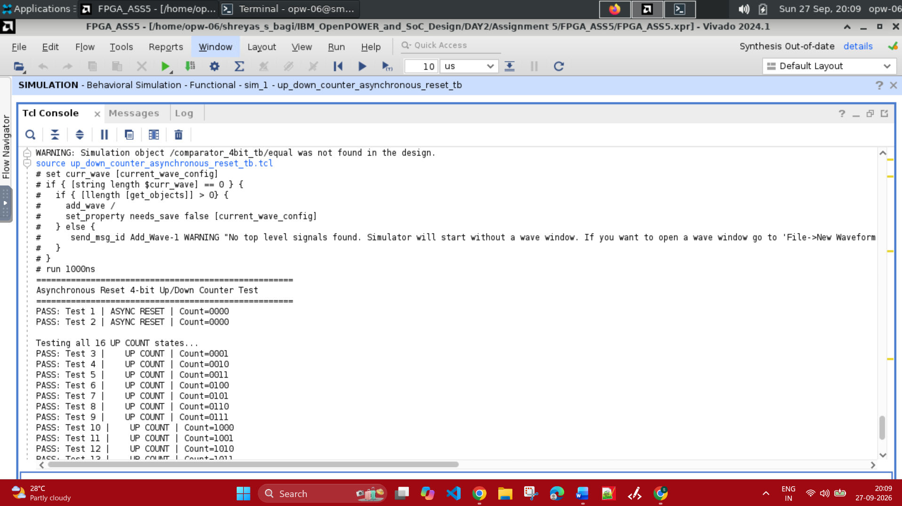

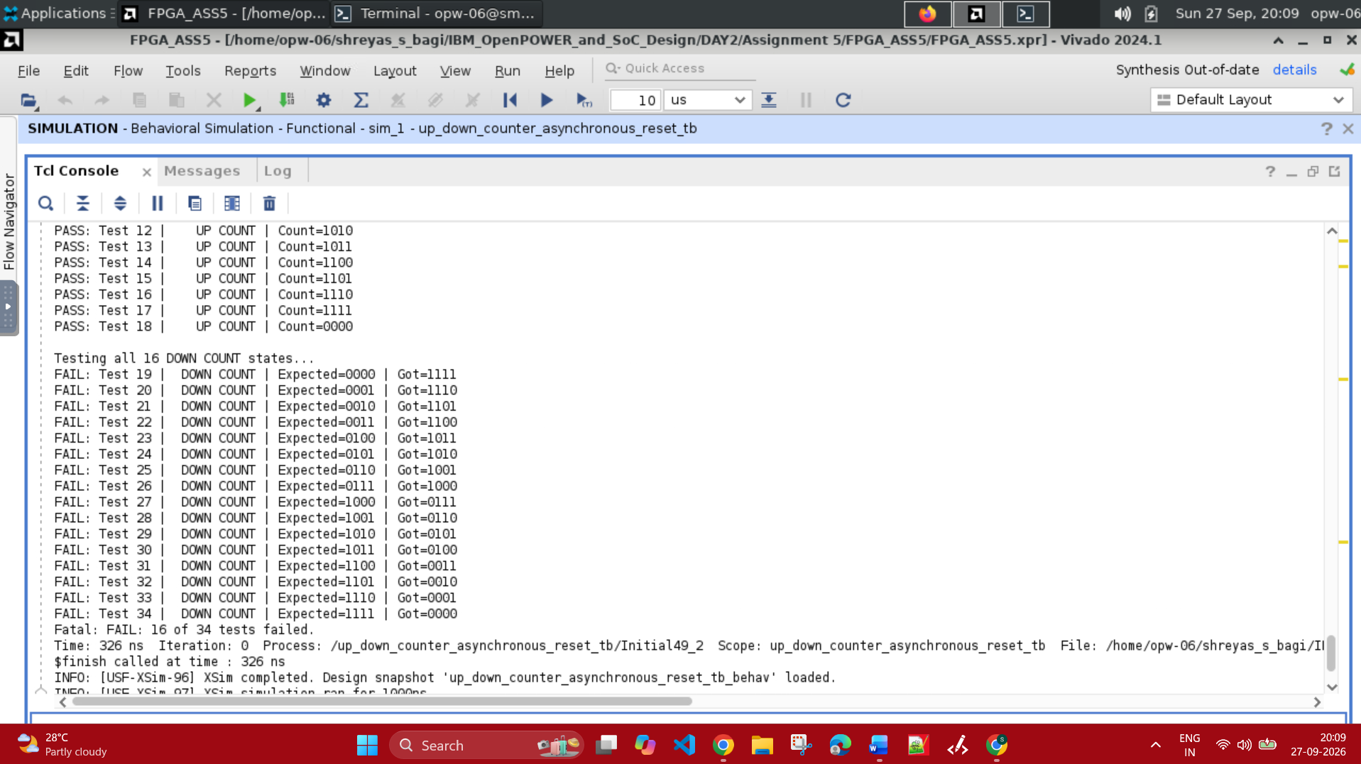

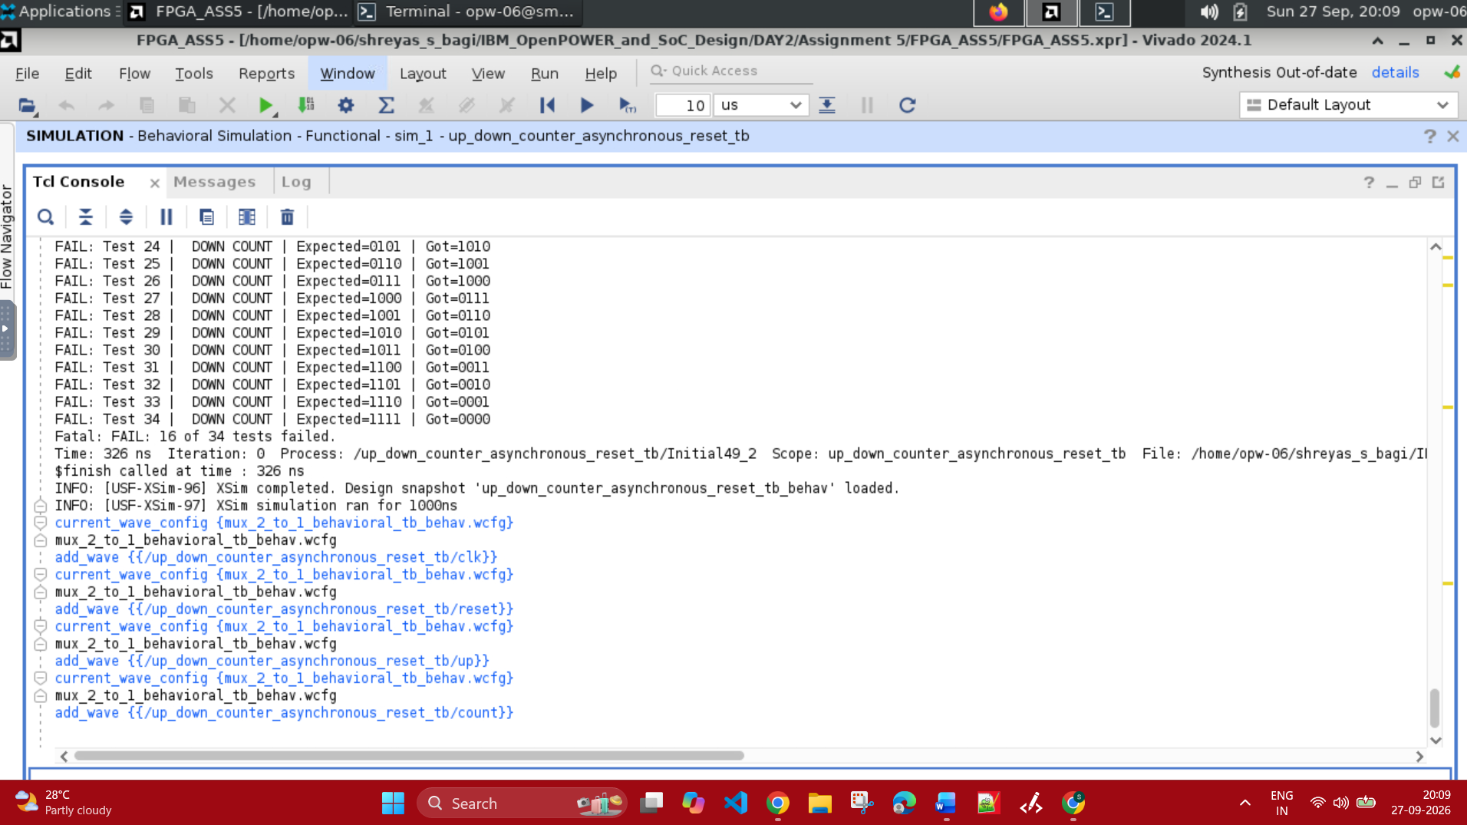

Simulation Waveform :
The Up Count when up = 1 and Down Count when up = 0.
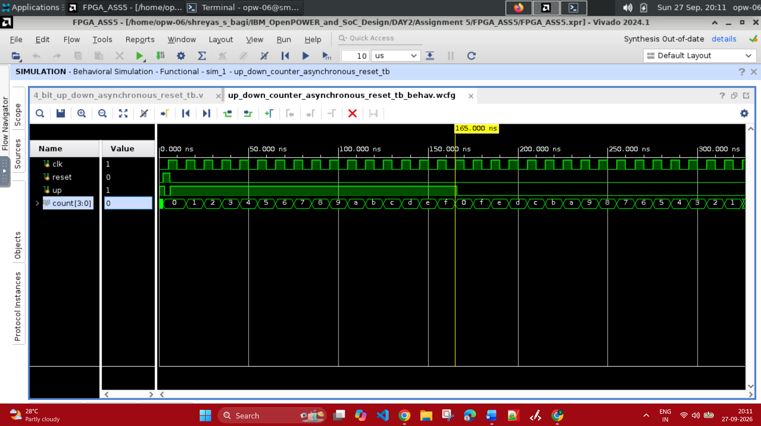

Asynchronous Reset :
If we observe as at the Time = 2ns. We make the reset = 1 irrespective of the clock edge the changes are taken into effect hence we see count value transition from the Logic X to Logic 0.
